Health apps

By Preeti Moda

Abstract:
The health apps that are currently being used in mobile devices like phones, wrist bands etc are playing an important role in the lives of people who are conscious about their health or who have to take real care about their health conditions. This paper gives an idea of the apps that are available which makes this possible and also throws some light on the future apps and how they can affect human lives. This paper also gives some knowledge regarding some of the apps that are currently being used like weight watchers etc.

Introduction:
Health apps consist of different kinds of assistance from mobile devices in maintaining health of the person. These kinds of applications are very useful in places where health facilities may not be fully available but mobile signals are abundant. The kinds of assistance which we can expect from such apps are keeping a daily track on the person’s heartbeat, taking readings of the blood insulin level and informing doctor if the patient’s condition changes. Health apps can also be used to keep track of weight of person. Some apps can provide suggestions as to what food can be consumed to consume lower calories and what exercises can be done to keep one’s body in shape. More than 1 billion dollars are being spent on health care in United States. This itself shows how much people are concerned about their health. So this has become a potential market these days. Many apps are being developed which provide some type of health care like iPhodometer, Limeade, iPhone Nutrition, Sugar Tracker etc.

How to build an iPhone app:
To understand about the various health apps being used let us consider how an app is built. For this purpose we have to download an iPhone SDK. We use Xcode to create an app. We have to create a new project and then name it accordingly like “HelloWorld” or something similar. Then the app is launched using main method defined in sources folder. We have to use an Interface Builder to design our application. We can create a new view and add controls to it depending on the requirements of the app. Then we have to connect the instance variables and elements to the view for the controls to work. Finally we have to implement the view in our application for the project to run. This is an outline of how to create an app on mobile phone.(iPhone)

The three circles!!
Pervasive computing is mainly a combination of computation, communication and intelligence.

Health App #1
The first health app about which we have to know is Weight Watchers. The features of weight watchers are as follows:It has food menu,tracker menu,recipes which have been approved by experts for dieting purposes,taking care of fitness is helped by video demos ect,calculator menu which is used for calculating the calories,Meeting locator option which helps in locating the nearest meeting location where advice on diet control and exercises are being given.

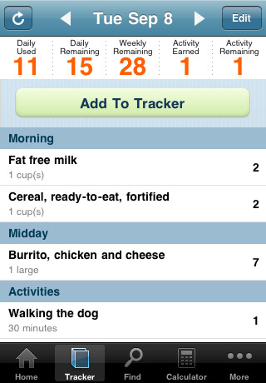

The tracker menu is shown in figure above.
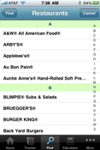

In the food menu or restaurant guide, we select the restaurant, then the food item which we want to have. Then we have to select our serving size, the time of day we ate the meal, and the point value automatically enters into our tracker.This tracker menu helps in maintaining the correct weight by giving information about the calories being spent and calories that we are allowed to spend.
In the find menu we can find food, meals, recipes, restaurants, favorites, recently added and activities. Adding “activities” to our tracker is easy. Select from a huge list of activities, enter the time and it automatically enters the point value on our tracker.
“Optimize My List” is the fastest way for a user to making changes to the list. By pressing the “Optimize My List” button, the application will automatically change all the items into the least point items available, and show how many points user will save to make all those changes. We hope showing the points the user will save in total will be an encouragement for users to make changes. Of course, the user can choose to accept this changed list by pressing “Confirm”, or refuse it by pressing “Cancel”. Also, the user can still make changes to certain items in the list and then confirm the list.
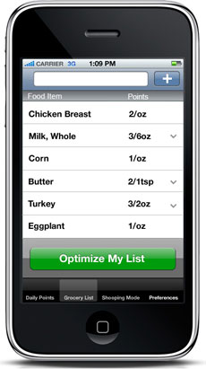
If there is any specific item the user doesn’t want the application to suggest, by slashing the item and press the button “Do not suggest again?” will delete this item in the suggestion list and never suggest it again, unless the user changes it back in the preferences.
The main interface of the application is a grocery list. Users can type in grocery items in the top input bar. There is an automatic completion and voice recognition functions to make input easier and faster. After the user confirms one item by pressing the “+” button, the item will show on the list with its points. If there is a healthier substitution for an item the user has chosen, there will be a down arrow in the line of that specific item. By pressing that arrow, a drop down list with all the substitution suggestions will appear, with the points of each item. We have a drop down list instead of opening a new page to make the changing-item process faster. If the user decides to choose one of the substitution, he/she has to just press the item required. If the user wants to know more about why we suggest a certain item, pressing the information icon will give them the answer.
We have intelligence in this app as this suggests the alternative food instead of our chosen ones in order to consume lower number of calories.This app is very useful for people who want to lose weight and maintain a healthy figure.

Health App#2:
The second app is weight tracker.This is a very simple app which mainly helps in tracking a person’s weight and is not intelligent.We can know the history and weight journal of a person on weight tracker.The below screen shots helps in understanding the features of this app better.
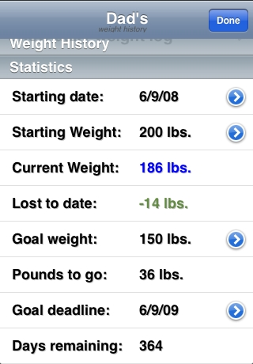

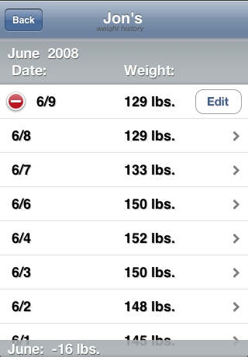

This app just computes the moving weight of the person and gives statistics in the form of graph.It also connects to the website and uploads all the data entered into the app into the database online.Hence it maintains connectivity.

From the study of two apps above we can see that the first app is better than the second one because of more features and also because the first one has intelligence.

Lifescan app:
This app connects to glucose monitor machine through Bluetooth and it monitors the blood glucose levels.This is very useful for diabetic patients. If a patient chooses to send their reports or a summary of reports to their doctors then they can do that. For example, we have a high school-aged daughter with diabetes and the parent wants to make sure they were testing and doing it appropriately. The child can test their glucose, then decide what they’re going to have for lunch, make the necessary calculations to insure their insulin levels will be managed and then send all that information to the parent who can have peace of mind knowing she did test when she was supposed to.

Other apps which use technology and help in maintaining health:
iSign is an app which helps in communicating with persons with hearing disabilities. Although it is very limited, with only 164 gestures to date, iSign could become a very powerful and important product.
Its vocabulary is currently very limited. If any person is speaking sign language or is learning, it’s worth supporting this developer’s cause, but some additions are warranted.

One more app which is interesting was developed by Hitachi.They developed a watch which in addition to displaying time has some additional features. In actuality, this wristwatch-type terminal measures user vitals such as pulse, skin temperature and motion around-the-clock, 24 hours a day. We have to slip it over wrist, just like a watch. Onboard sensors measure pulse, skin temperature, motion and other items, and log the data to internal memory. The data can be transferred to a personal computer (PC) via a wireless link, and then used by a special application to estimate things like number of paces walked, activity (calories consumed) and sleep time. Data is graphed, making it easy to see changes over time. For example, the graph function can be used to review activity for the day. This is a very useful application which is a kind of life saver.
One more app which was very interesting was developed by LG.It is a cell phone which in addition to working as a normal phone also has a tester into which users can place a blood test drop on a strip, place the strip in a special reader on the phone (located near the phone's battery pack), and get insulin and blood readings on the phone display. Readings can then be uploaded to an online database for retrieval later on.
One more app which was interesting was mobile phone-mounted light microscope and it has potential for clinical use by imaging P. falciparum-infected and sickle red blood cells in brightfield and M. tuberculosis-infected sputum samples in fluorescence with LED excitation. In all cases resolution exceeded that necessary to detect blood cell and microorganism morphology, and with the tuberculosis samples the developers had in advance added further advantage of the digitized images to demonstrate automated bacillus counting via image analysis software.Such a telemedicine system is expected for global healthcare via mobile phone – offering inexpensive brightfield and fluorescence microscopy integrated with automated image analysis – to provide an important tool for disease diagnosis and screening, particularly in the developing world and rural areas where laboratory facilities are scarce but mobile phone infrastructure is extensive.
Future additions to the apps discussed to make them better:
We can add pedometer which counts number of steps to the weight watchers app or apps similar to them.With this addition,the number of steps taken by a person and in turn the number of calories burnt by the person in order to do so can be automatically calculated. This adds intelligence to the app. We can also use the inbuilt GPS system in the phones to track the person’s position and give suggestions on the restaurants available and food items which can be consumed in those restaurants which can be of low calories.Such small additions can enhance the intelligence and usefulness of health apps immensely.
Conclusion:
The ever-growing technology has made it possible for doctors to treat the patients without actually being present with them and people to maintain their fitness without consulting their nutritionist and gym supervisors through various health apps available.It may not be surprising that in few years we may even have apps that can do laboratory work and help in giving suggestions and medications.
References:
1) http://www.iphonesdkarticles.com/2008/07/first-iphone-application.html
2) http://www.nursingdegree.net/blog/28/ifit-50-coolest-fitness-and-health-apps-for-the-iphone/
3) http://www.docshop.com/2008/09/07/top-10-health-applications-for-the-iphone/
4) www.WeightWatchers.com

